Grant Agreement No: 262025
AIDA
Advanced European Infrastructures for Detectors at Accelerators
Seventh Framework Programme, Capacities Specific Programme, Research Infrastructures, Combination of Collaborative Project and Coordination and Support Action

deliverable report

[Integrated Infrastructure for Highly Granular Calorimeters]

Deliverable: D9.7

Document identifier: | AIDA-Deliverable-9.7-v4.docx
Due date of deliverable: | End of Month 47 (December 2014)
Report release date: | 31/01/2015
Work package: | WP9: [Advanced infrastructures for detector R&D]
Lead beneficiary: | DESY
Document status: | Draft v4 [Final when fully approved]

Abstract:
This deliverable document summarises the steps for the establishment of an European infrastructure for studying and realising highly granular calorimeters.

VERSION 4 for distribution to work package leaders, 22/12/14.

Copyright notice:

Copyright © AIDA Consortium, 2015.
For more information on AIDA, its partners and contributors please see www.cern.ch/AIDA

The Advanced European Infrastructures for Detectors at Accelerators (AIDA) is a project co-funded by the European Commission under FP7 Research Infrastructures, grant agreement no 262025. AIDA began in February 2011 and will run for 4 years.

The information herein only reflects the views of its authors and not those of the European Commission and no warranty expressed or implied is made with regard to such information or its use.

Delivery Slip
 | Name | Partner | Date
Authored by | R. Pöschl | [CNRS] | 19/12/14
Edited by | R. Pöschl | [CNRS] | 24/12/14
Reviewed by | F. Sefkow [Task coordinator]  M. Vos, V. Boudry [WP coordinators]  L. Serin [Scientific coordinator] | [DESY]  [IFIC, CNRS]  [CNRS] | 24/12/14
Approved by | Steering Committee |  | 31/01/15

TABLE OF CONTENTS
1. Introduction 4
2. SUMMARY OF INDIVIDUAL Achievements 6
2.1. SILICON Tungsten electromagnetic calorimeter 6
2.2. ANALOGUE HADRONIC CALORIMETER - AHCAL 7
2.3. SEMI-DIGITAL GRPC Hadronic CALORIMETER – GRPC-SDHCAL 8
2.4. Tungsten TEST BEAM structure 9
2.5. FRONT END ELEctronics 9
2.6. Forward calorimeter 10
3. More Content (landscape format) 12
4. Summary and outlook 13
5. References 14
Annex: Glossary 16

Guidance notes (to be deleted from deliverable itself)
Deliverable Reports are committed contractual outputs of the project and must be sent to the EC according to the timetable indicated in Annex 1 of the Grant Agreement.
* N.B. Each Deliverable has to be associated with a written report, regardless of its nature, e.g. web-site, device, specification, etc.

Workflow (to be deleted from deliverable itself)
Lead Beneficiaries assemble & produce deliverable report. (due date of Annex 1 + 10 days)
Task and WP Coordinators review and validate deliverable within 20 days of receiving it.
Scientific Coordinator sends deliverable to the Steering Committee for review and approval, then the report is deemed “final” and is submitted to the EC.

Executive summary
In the course of the AIDA project technologies proposed for highly granular calorimeters have made a significant step forward.
The prototypes of electromagnetic and hadronic calorimeters have allowed for validating the concept of highly integrated, low-power front-end electronics. Innovative technologies for scintillating tiles as active material of highly granular calorimeters were tested with the help of the developed infrastructure.
The principle of gaseous calorimeters with Resistive Plate Chambers could be validated in large-scale beam tests and motivates the development of large gaseous chambers. In addition it allowed contributing to the development of novel high rate RPCs.
Tungsten has never been used as absorber material for hadron calorimeters. At the end of AIDA, a tungsten absorber structure exists and served already for large-scale beam tests with different sensitive materials (scintillating tiles and RPCs). Results of these beam tests are already published in peer-reviewed journals.
In general the developed calorimeter infrastructures and the network of experts that has been formed enable the European groups to conduct large-scale beam tests with advanced prototypes. Non-European groups have been joining these beam tests. This underlines the attractiveness of the research programme on international level.
The front-end electronics features common building blocks for most of the calorimeter prototypes. The ASICs have been validated in beam tests and results will be published in a peer-reviewed journal. The successful operation yields to the development and production of 3rd generation ASICs experimenting full on-chip zero suppression and I2C links for communication.
Forward calorimeters will have particular requirements in terms of radiation hardness and rate tolerance. Within AIDA an infrastructure has been developed that enable European groups to conduct a comprehensive beam test programme. For these detectors novel readout ASICs are under development and approach fabrication.
Note, finally that the mentioned beam tests benefitted from funding through the AIDA TA.
[This text (in italics for emphasis) needs to summarise the entire deliverable document in a clear, succinct form.
It could have short paragraphs, each paragraph summarising the content of one section in the document, so that the main points are covered.
Please note that this deliverable report will be publicly available on the AIDA website and will also be sent to the European Commission]

Introduction
[Text to explain how this work fits into the AIDA project, any relevant background work and the scope of this deliverable
Can be a few paragraphs long.
A page break separates this introduction from the content that follows]
Highly granular calorimeters are present in all selected concepts for future detectors in high-energy particle physics near accelerators. The technique adds the qualitative new feature of particle separation inside the calorimeter by tracking. The terms Imaging or Tracking calorimeters describe this possibility very well. The AIDA project helped to make significant progress towards the realisation of this new kind of detectors. The participating groups have created a network of detector infrastructures to test various types of integrated detector elements, featuring e.g. analogue readout with scintillator and silicon (or GaAS) sensors and (semi)-digital readout of gaseous resistive plate chambers (GRPC). The effective cooperation and sharing of infrastructures through AIDA within this R&D allowed for the realisation of a number of beam test campaigns that render the proof of the feasibility of the different proposals for imaging calorimeters.
The acquired know-how will be useful for a sustained development of the technology in the near future. All calorimeter prototypes (at the exclusion of the Forward Calorimeter, presenting very specific requirements) are read out by ASICs and digital electronics that are designed around common functional circuit blocks. This common approach creates enormous synergies needed for a deep understanding of the highly integrated devices.
The technologies studied in this work package have already given rise to spin-offs in other fields of science and technologies. For example, the ASICs and silicon photomultipliers (readout of scintillator calorimeters) are applied in medical applications such as PET scanners.

SUMMARY OF INDIVIDUAL Achievements

As indicated in the introduction the R&D for granular calorimeters comprise various different sensor and readout technologies. The main achievements of these technologies are sketched in the following. Note that the work reported thereafter constituted a major input for the Technical Design Report of the ILC in the detectors volume [8].

SILICON Tungsten electromagnetic calorimeter
The SiW-ECAL detection elements (dubbed SLABs) are built upon one or several 18×18 cm² modular units coupled to an interface board. Each unit consist in of up-to 4 wafers of 9×9 cm² segmented in 5×5 mm² cells, readout by 16 SKIROC2 ASICs, through a thin PCB. The units are maintained by a Carbon-Fibre structure. The design and production of these units is a complex task implying intertwined instrumental, mechanical, electronics and thermal aspect, which is done incrementally. AIDA contributed to support these activities.
Beam tests with up to eight short SLABs with a detection area of 9×9cm² (a single wafer) have been performed in 2012 and 2013. A scalable and compact DAQ system based on adapted Ethernet protocol and HDMI cables has been brought into operation for the beam tests. The detector is configured using XML and python scripts [4].
The results for 2012 were reported e.g. at the VCI conference at Vienna [5] and the paper publication got recently accepted by a peer-reviewed journal [3]. The Signal-over-Noise ratio is found to be always above 10:1 for different settings of the SKIROC2 ASIC. For a better detector understanding a simulation chain has been developed that e.g. is able to reproduce the position of the MIP.
During the beam tests in 2013 the detector was operated in power pulsing mode. Power pulsing implies a periodical shutdown and re-launch of the bias currents that polarise the various stages of the ASIC. In general the results obtained in power pulsed mode and in normal mode agree very well with each other. With the conclusion of the beam tests in 2012 and 2013 small design defects were found and corrected, validating the concept and implementation of the ECAL layers. The next step is to produce a stack of layers with dimensions 18×18cm² (4 wafers). For this interface cards for 16 ASICs (in contrast to 4 up to know) have been developed. These are at hand now and are tested in the laboratory. The fabrication of these layers requires gluing four wafers onto the interface cards. This is a delicate procedure since the wafers are fragile and expensive. A gluing robot is under development and the technology is now tested with unprocessed wafers that have the same mechanical characteristics as ‘real’ wafers. It is expected that first layers will be produced starting from January 2015.

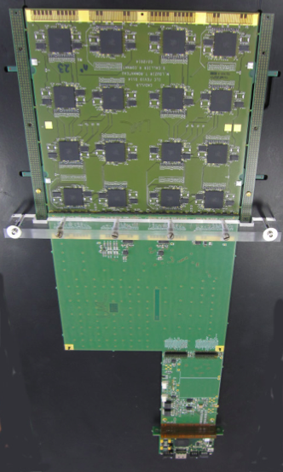
Figure 1 : PCB with ASICs for 18×18cm².SiW-ECAL.

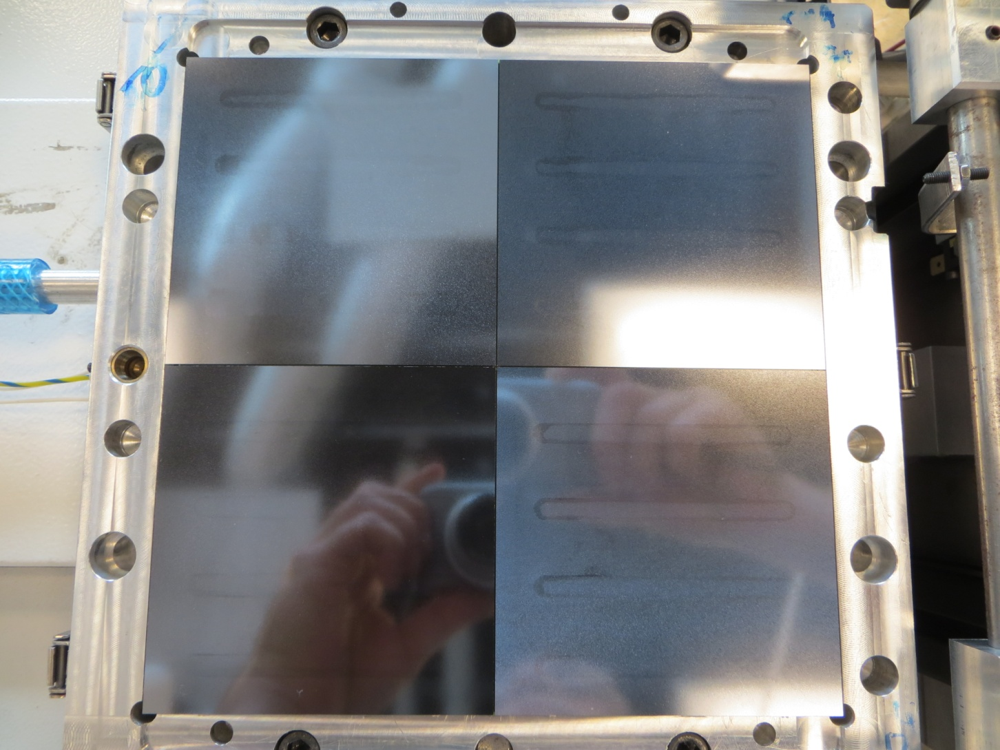
Figure 2: Four (fake) Si wafers glued onto a PCB of the SiW-ECAL.

ANALOGUE HADRONIC CALORIMETER - AHCAL

For the analogue HCAL active modules were developed during the AIDA project. The realisation of these new modules is based on a network of groups working on the optimization of the design with respect to the uniformity of the response and the ease and cost of production. This allowed e.g. for the first time to test fibreless scintillating tiles while keeping a good uniformity of the response. Readout electronics similar to that of the silicon ECAL described before is used. The efforts culminated recently in a beam test with hadrons at the CERN PS.
The goal of the beam test was to realise a system test on the first large set of calorimeter layers. Naturally, the other goal of the beam test was to record a first set of data that allow for detector calibration and to determine the electromagnetic response before assessing the performance for hadrons. Altogether 8 small layers featuring 1 HBU and four big layers featuring 4 HBUs were tested. The layers were integrated in the steel structure with shape and size compatible with a large detector such as ILD. In the future the channel wise power supply, developed within AIDA, will be integrated into the setup.
It is worthwhile to note that this beam test has been conducted in common with an electromagnetic calorimeter that is also based on the scintillation technique as well as recently with one layer of the SiW Ecal layers mentioned above. This proves that the infrastructure for combined calorimeter beam tests is operational. This will be exploited in the future for e.g. common beam tests at bigger scales.

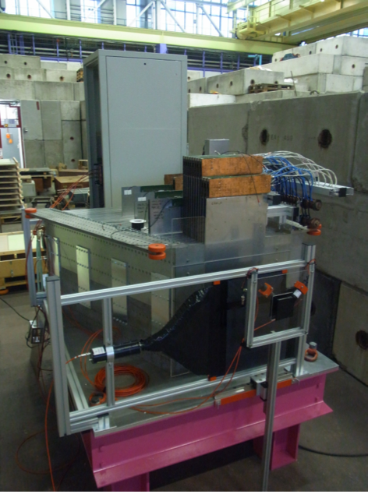
Figure 3: Analogue HCAL absorber structure with inserted layers.

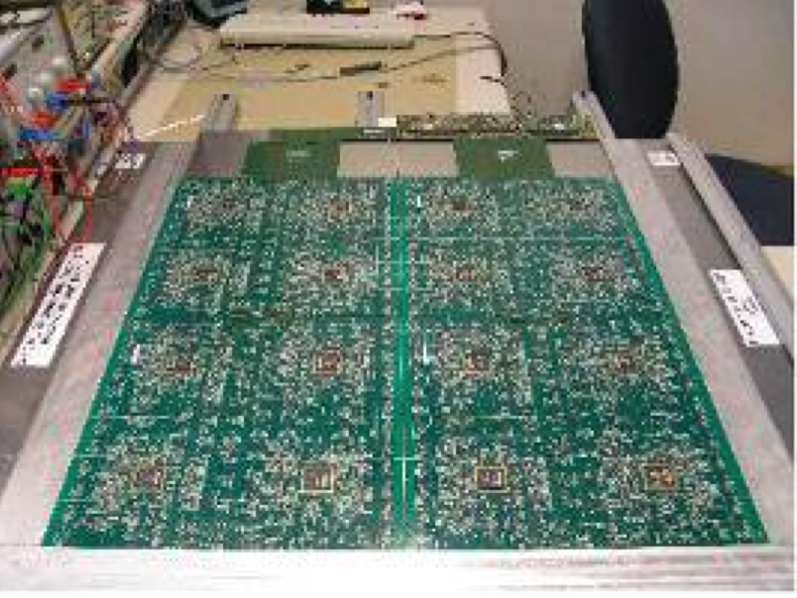
Figure 4: Electronic board for analogue HCAL prototype.

SEMI-DIGITAL GRPC Hadronic CALORIMETER – GRPC-SDHCAL

Activities of the Semi-digital hadronic calorimetry using Glass Resistive Plate Chambers (GRPC) were pursued on two tracks. First, the technological calorimeter prototype was completed and the study of this first technological prototype has started after exposure to particle beams of different kinds at CERN.
The first results validate the concept. A further GRPC-SDHCAL run took place in December 2014. The setup comprised 50 chambers of 1 m² plus 6 optional chambers of 30×30 cm².
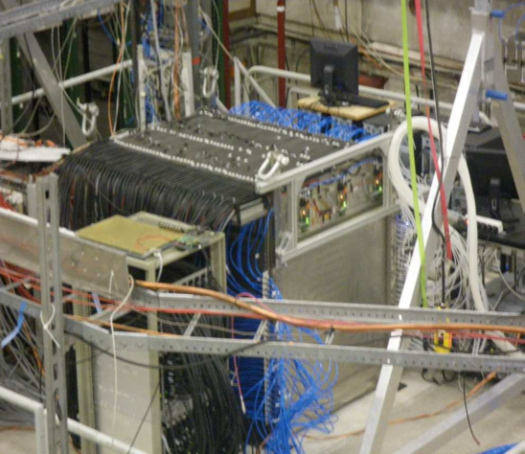
Figure 5: 1m3 GRPC-SDHCAL stack.

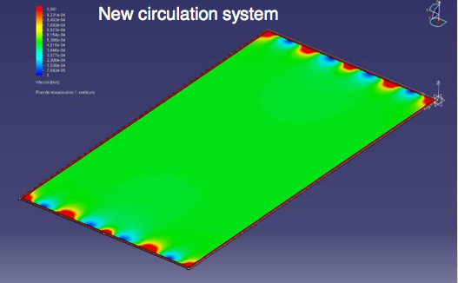
Figure 6: Mechanical simulation of 2x1 m2 chamber showing effect of new gas circulation system.

Development of new Particle Flow Algorithms using the high granularity of such prototype is on going.
The second track concerns the development of large RPC detectors (2-3 m²) and their readout electronics as well as the design of a self-supporting mechanical to host them. For the large detectors, a new gas distribution inside the RPC detectors was conceived. It allows irrigating efficiently with the gas inlets and outlets on the side. A few RPCs of 2 m² will be built soon using this system. The new HARDROC3 ASIC improves the readout of RPC detectors with both the zero-suppression and I2C protocols. Electronics boards adapted to large detectors with reduced cost are being designed.
The work on the chambers as introduced above opened the possibility to work on chambers that can sustain high rates, i.e. bigger than 100 Hz/cm². Beam tests with this kind of chambers were conducted in 2013 at the DESY beam test facility [6].

Tungsten TEST BEAM structure
While the tests with hadronic calorimeters described above used steel as absorber material the AIDA project encompassed the construction of a structure with tungsten as absorber material. This structure hosted layers with different sensitive materials (Scintillating tiles, Glass RPCs).
Two papers based on these measurements were recently published [1], [2].
With minor modifications this structure can be used in future beam test experiments, thus helping to establish tungsten as a viable absorber material for hadronic calorimeters in future experiments. It may allow to keep the detectors compact while measuring particle jets in the
Multi-TeV range.

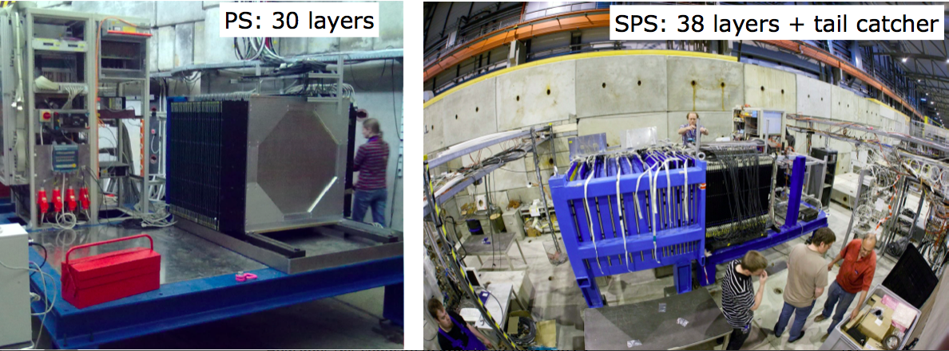
Figure 7: Tungsten absorber structure in the PS and SPS beam test areas at CERN.

FRONT END ELEctronics

The beam tests with the prototypes as described above have allowed for a validation of the highly integrated design of the ‘ROC ASICs’ (SKIROC2 [SiW Ecal], SPIROC2 [AHCAL], HARDROC2 [GRPC-SDHCAL], MICROROC [SDHCAL with Micromegas]). As a reminder these ASICs combine signal pre-amplification and triggering, signal shaping and digitisation in one single unit. The bias currents can be periodically shut down, a feature also known as power pulsing to save power (and heat dissipation) when used with a pulsed accelerator such as the ILC. A 3rd generation of ROC chips was developed, where the channels are handled independently to perform on-chip zero suppression. This is a major modification, especially for the digital part, as it implies a complex management of the readout. Besides, an I2C link with triple voting for radiation tolerance was integrated for the control of the ASIC to allow for the handling larger number of chips in a single detector unit.
HARDROC3 is the first of the 3rd generation ASIC. A small number has been produced in a first engineering funded through AIDA. HARDROC3 is the simplest of the ROC chips since no major modifications of the analogue part were needed. First results on a test bench show the good performance of the ASIC. In particular the I2C link works very well. A larger number of HARDROC ASICS together with updated versions of the ASIC mentioned at the beginning will be produced in an upcoming engineering run scheduled for January 2015. Again this engineering run will be in large parts funded by the AIDA support.
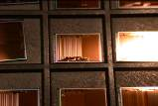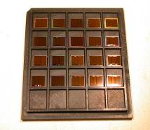
Figure 8: HARDROC3 naked dies.

Forward calorimeter

A multilayer tungsten structure was built (Fig.9). It includes: mechanical structure housing up to 30 sandwich type Si-W modules, ten precisely thinned (accuracy of ~50um) Tungsten absorber plates, and four prototype detector modules, each one containing a Si or GaAs pad sensor, a 32-channel readout board with dedicated front-end and ADC ASICs and a FPGA based back-end electronics [7]. After commissioning the functionality of the multilayer calorimeter structure was demonstrated with beams of hadrons, muons and electrons. Results on the performance of the first calorimeter prototype will be obtained soon from the analysis of the test- beam data. Further prototype structures of a laser alignment system based on a) semi-transparent silicon sensors for relative measurements in transversal direction, and b) Frequency Scanning Interferometry (FSI) for absolute position measurement, were built [10]. Preliminary measurements demonstrated its feasibility for the final alignment system. The built infrastructure will be used in future test-beams of forward calorimeters, in particular for the BeamCal and LumiCal studies.
For the multichannel readout, two ASICs were designed and fabricated in deep sub-micron CMOS 130 nm technology, an 8-channel front-end ASIC (Fig. 10) and an 8-channel ADC ASIC (Fig. 11). The parameters meet the requirements [7], [8]. The performance of the two ASICs is similar to the existing ASICs built in older CMOS 0.35um technology and mounted on the present 32-channel readout board. However, the new ASICs fulfil all critical requirements of the final calorimeter. In particular, they dissipate an order of magnitude less power, they have power pulsing implemented, and they are radiation-hard. These new ASICs will be the core of a next generation compact detector module.

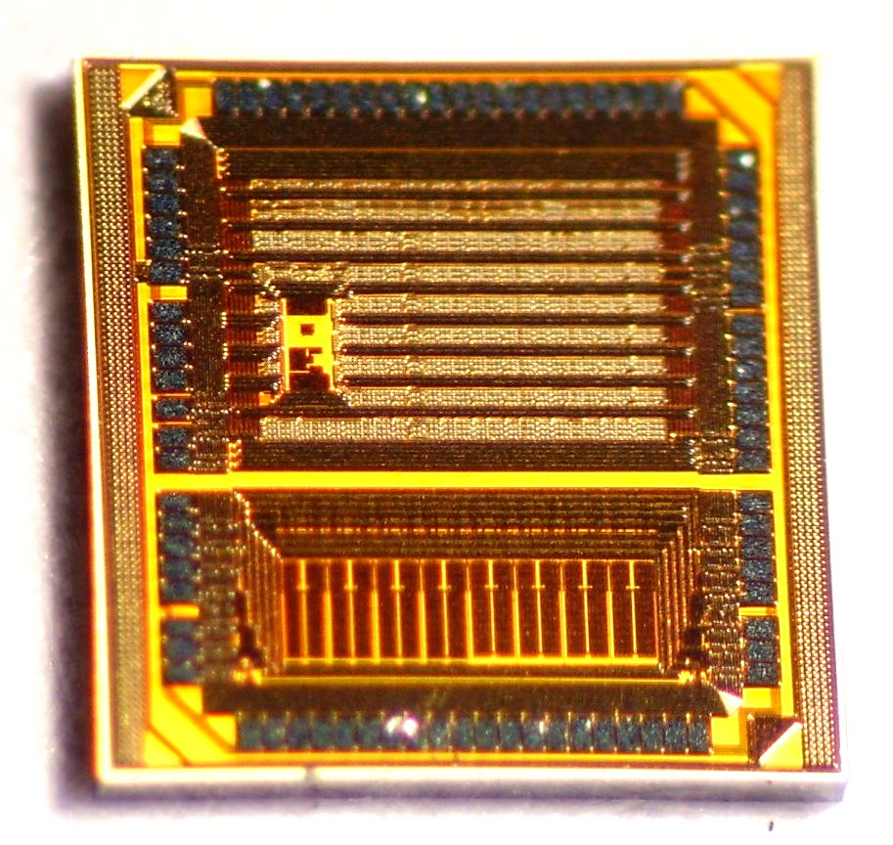
Figure 11: 8-channel ADC ASIC for forward calorimeters.

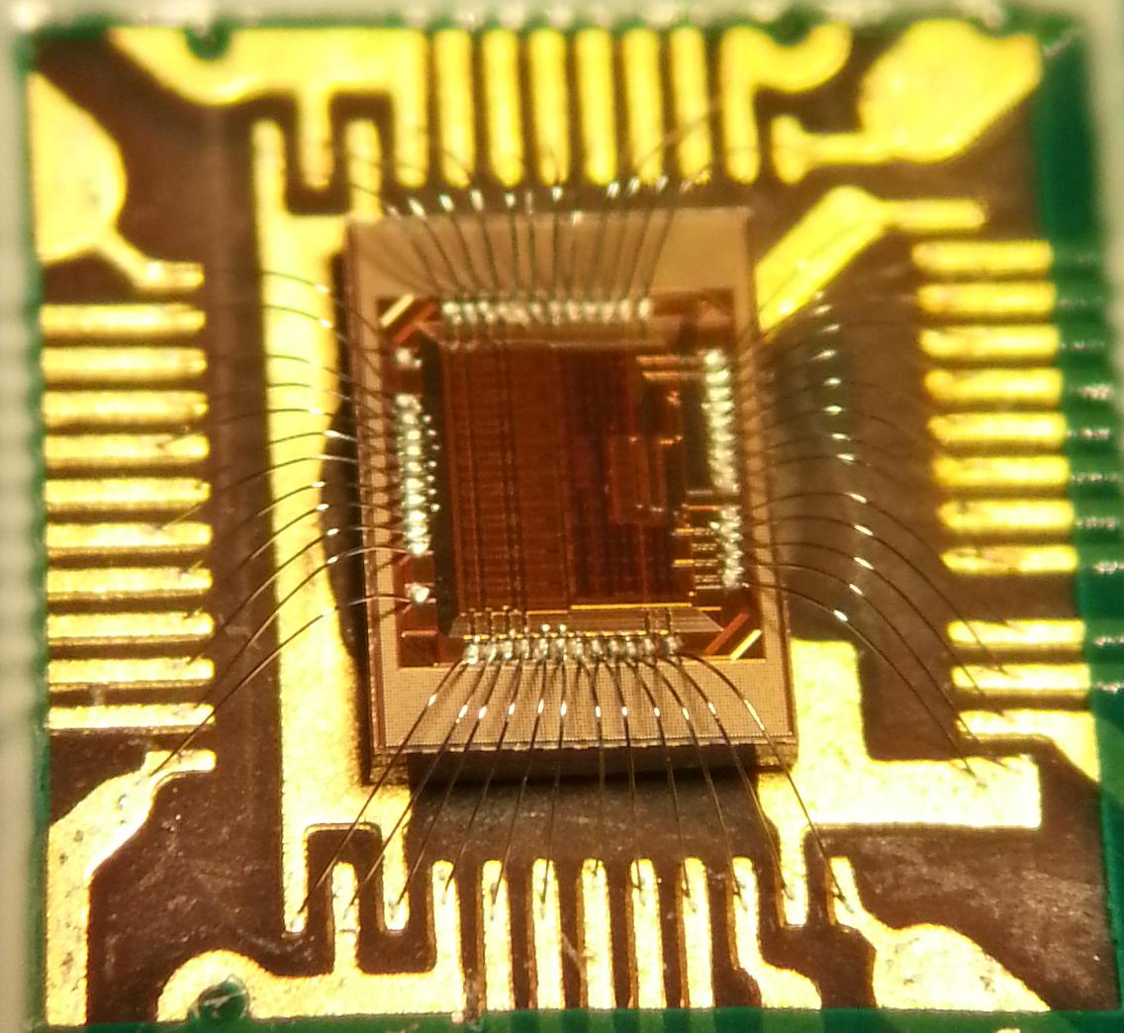
Figure 10: 8-channel front end ASIC for forward calorimeters.

Figure 4: 8-channel front end ASIC for forward calorimeters.

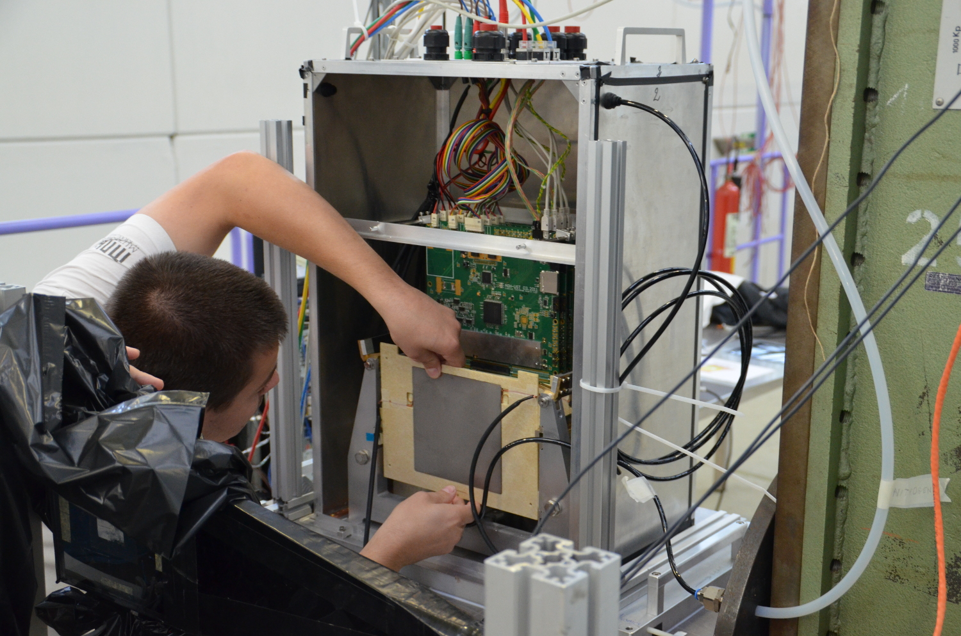
Figure 9: Multilayer tungsten structure for forward calorimeters at e+e- machines.

More Content (landscape format)

Summary and outlook
[Text to end the document, either mentioning future plans, some sort of conclusion or how this work relates to other work within the AIDA project. Use your judgement to find a suitable heading for a short end-section for the deliverable]
At the end of the AIDA project we are one step further on the way towards the realisation of highly granular calorimeters. Various variants of this calorimeter type were built and successfully tested. Interoperability among these prototypes is supported by the use of readout devices such as the ASICs that have a number of blocks in common. The same observation is true for the digital part of the readout electronics. The next step should be indeed to prove the combined running of the prototypes. A combined running with large-scale prototypes that incorporate recent technological approaches and that will deliver high quality physics results (e.g. on hadronic showers) will render credible that these systems can indeed be proposed for future experiments at high-energy colliders.
Beam tests conducted with the prototypes require collaboration with the WP2 on software. We need to simulate the setup. For this the new DD4HEP tool could be applied. The recorded data may serve as real life tests for the Particle Flow Algorithms that are developed in this package.

References
AIDA references are based loosely on the Harvard System of referencing. In the text, references should be marked by numbers in square brackets [x]. Then in this “references” section, they are listed by number using the following styles:

JOURNAL ARTICLES:
[1] Adloff C. et al., CALICE Collaboration (2014). Shower development of particles with momenta from 1 to 10 GeV in the CALICE scintillator-tungsten HCAL, JINST 9 P01004, arXiv:1311.3505.

[2] Adloff C. et al., CALICE Collaboration. (2014). The Time Structure of Hadronic Showers in Highly Granular Calorimeters with Tungsten and Steel Absorbers, JINST 9 P07002, arXiv:1404.6454 .

[3] Frisson T. et al. (2014) Beam test performance of the SKIROC2 ASIC. To appear in: Nucl.Instrum.Meth, Vol. A.

CONFERENCE PAPERS

[4] F. GASTALDI, R. Cornat, F. Magniette, and V. Boudry. 3rd international conference on technology and instrumentation in particle physics (tipp 2014). In Proceedings, 3rd International Conference on Technology and Instrumentation in Particle Physics (TIPP 2014) , April 2014.

[5] J. Rouëné et al. (2013) Construction and testing of a large scale prototype of a silicon tungsten electromagnetic calorimeter for a future lepton collider. In: Nucl.Instrum.Meth, Vol. A, no. 372, p. 470, 2013.

[6] Y. Haddad, G. Grenier, I. Laktineh, N. Lumb, and S. Cauwenbergh. High Rate Resistive Plate Chamber for LHC detector upgrades. Nucl.Instrum.Meth., A718:424–426, 2013., presented at 12th Pisa Meeting on Advanced Detectors: Frontier Detector for Frontier Physics.

[7] M. Firlej et al. (2014) Development of front-end electronics for LumiCal detector in CMOS 130 nm technology. In: TWEPP2014, submitted to JINST - in print..

[8] J. Moron et al. (2013) Development of variable sampling rate low power 10-bit SAR ADC in IBM 130 nm technology Presented at: TWEPP2013 23-27 September 2013, Perugia Italy

REPORTS
[9] T. Behnke et al. (2013) The International Linear Collider Technical Design Report – Volum 4 Detectors, ILC-REPORT-2013-040, arxiv:1306.6329 [physics.ins-det].

[10] H. Abramowicz et al., FCAL Collaboration. (2014) ECFA Detector R&D Panel, Status Report. In: arXiv:1411.4924v2 [physics.ins-det], November 2014.

Annex: Glossary
[You can either tabulate all acronyms with their definitions e.g.
Acronym | Definition
SiW Ecal | Definition of Silicon Tungsten Electromagnetic Calorimeter
AHCAL | Definition of Analogue Hadronic Calorimeter
SDHCAL | Definition of Semi Digital Hadronic Calorimeter
GRPC | Definition of Glass Resistive Plate Chambers
BeamCal | Definition of Beam Calorimeter
LumiCal | Definition of Luminosity Calorimeter
Or you can have a link to the AIDA website glossary:
http://cern.ch/aida/about/glossary/, making sure that you have provided the acronyms and definitions to AIDA-editor@cern.ch so that Kate/Naomi can update the web page accordingly. You are also welcome to have both the table and the link if you wish.

